2015 Baja SAE Design Comparison Document

[Insert School Name]

2014 Car Number 2015 Car Number

**[Insert 2014 Car Number]** **[Insert 2015 Car Number]**

[Insert Baja SAE Series]

 

# 

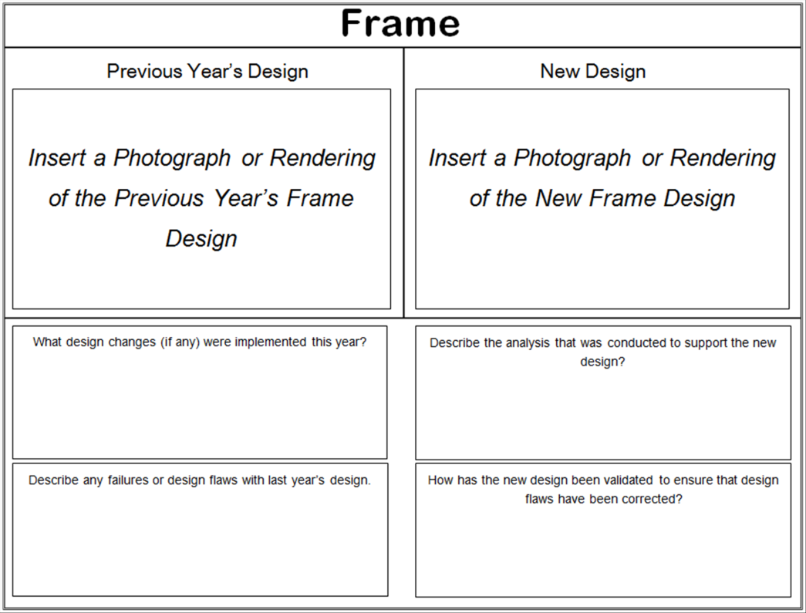

[Please list the analysis conducted]

[Please list any design changes to this system]

[Please list any failures or design flaws with last year’s design]

[Please list how the new design was validated]

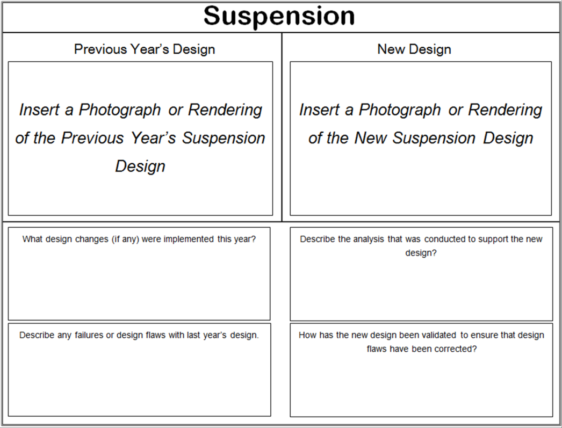

[Please list the analysis conducted]

[Please list any design changes to this system]

[Please list any failures or design flaws with last year’s design]

[Please list how the new design was validated]

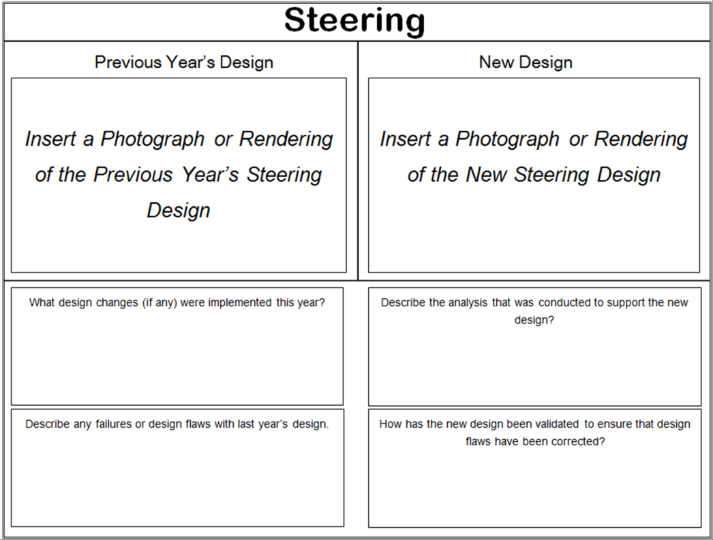

[Please list the analysis conducted]

[Please list any design changes to this system]

[Please list any failures or design flaws with last year’s design]

[Please list how the new design was validated]

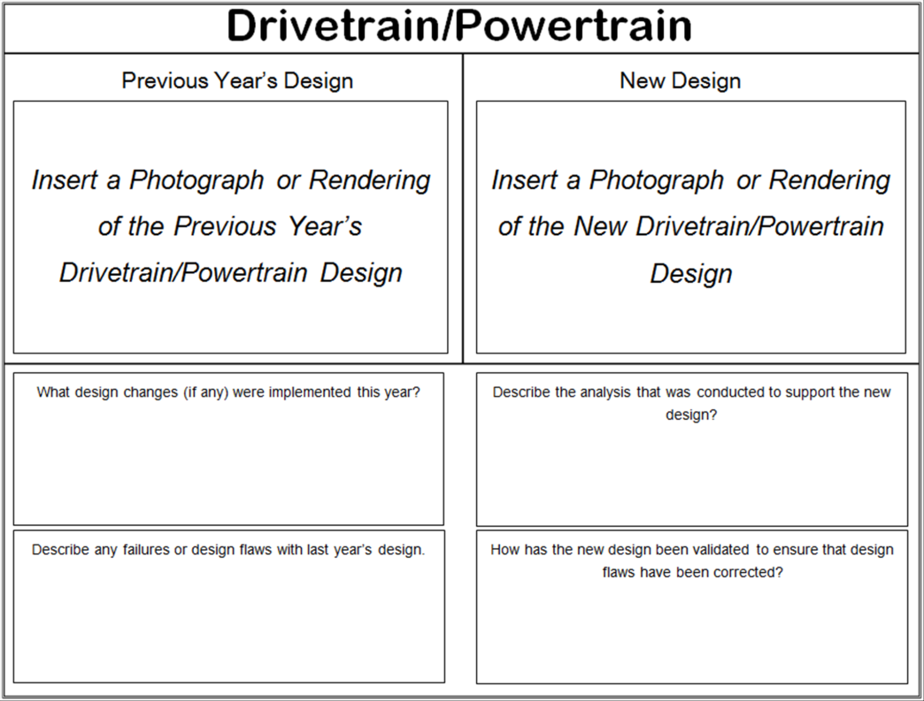

[Please list the analysis conducted]

[Please list any design changes to this system]

[Please list any failures or design flaws with last year’s design]

[Please list how the new design was validated]

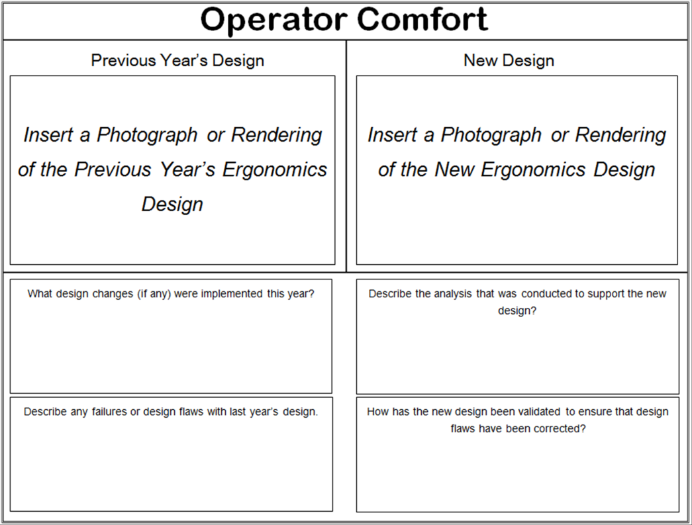

[Please list the analysis conducted]

[Please list any design changes to this system]

[Please list any failures or design flaws with last year’s design]

[Please list how the new design was validated]

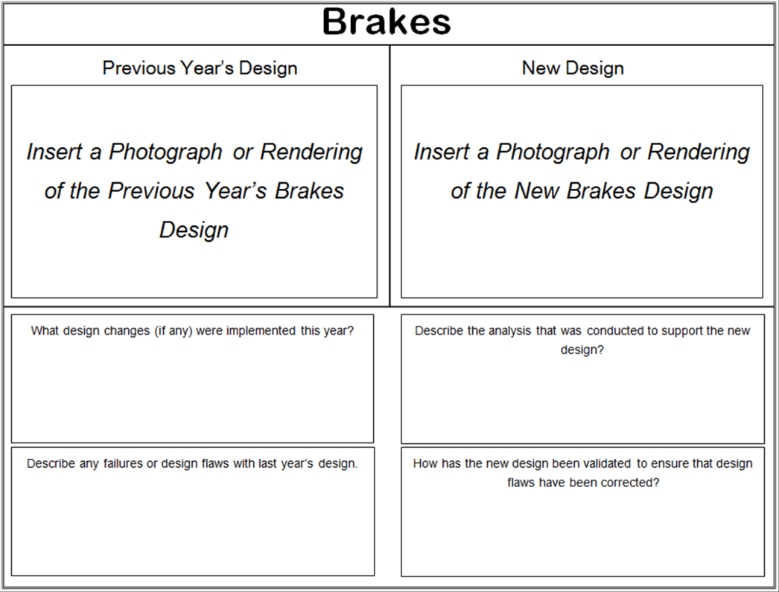

[Please list the analysis conducted]

[Please list any design changes to this system]

[Please list any failures or design flaws with last year’s design]

[Please list how the new design was validated]

# 

[Please list the analysis conducted]

[Please list any design changes to this system]

[Please list any failures or design flaws with last year’s design]

[Please list how the new design was validated]