

**2017 Baja SAE Design Evaluation Procedures**

The Design Evaluation at all competitions this year will follow the basic procedure as last year. Below you will find the procedure and general information regarding the Design Evaluation portion of the competition. Please familiarize yourself and your team with the process and the design section of the rules (C3.1) for an effective and efficient Design Evaluation.

**Procedures**

In initial (pre-Finals) Evaluation, each car will be evaluated once, at one bay, by one integrated panel of Design Judges. The score sheet is posted at [www.bajasae.net/go/downloads](http://www.bajasae.net/go/downloads) However, the total points will be determined by the judging panel as a whole, since the vehicle is judged as whole, and therefore may not match the sum of the categories.

Each competition team will begin its evaluation period by presenting a design overview of the car, delivered by one (or more) person (probably the Captain) to the entire judging panel (covering users, needs, specifications and values that guided the design process; key concept and configuration outcomes).

The members of the judging panel each have a specialty: drivetrain, frame/ergonomics, steering/suspension/brakes, and the bay leader (which will be evaluating the vehicle as a whole). After the team captain’s overview, the judging panel will separate into individual specialties, and each judge will look for team members to answer questions about more detailed elements of the team’s design. “Students will be judged on the creation of design specifications and the ability to meet those specifications, computer aided drafting, analysis, testing and development, manufacturability, serviceability, system integration and how the vehicle works together as a whole” (Baja SAE Rule C3.1.1). Each of these parts of the engineering product development cycle will be judged within the categories mentioned above.

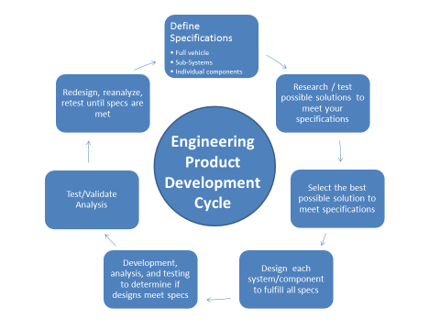

The Design Judges all have significant engineering experience and most have substantial experience in the design of Baja SAE vehicles. So that many schools of Baja thought are represented on each judging panel, judges from more than just the local colleges have volunteered to participate; hence many of these volunteers have traveled a significant distance, at significant personal expense, in order to contribute to Baja SAE educational outcomes in engineering education. Competition teams should strive to give the judging panels their professional best.

Each competition team’s Design Report has been read and scored by the same Design Judges as will staff that team’s judging panel for Design Evaluation at competition.

**Staging and Timeline**

All teams that submitted a design report have been assigned a Design Evaluation scheduled time and Bay. If your team did not submit a design report, your team will not be allowed to participate in the Design Evaluation. In the event that a team misses their time slot, there is no guarantee that the team will be evaluated, so please be prompt.

**Evaluation** **Layout**

There are eight design evaluation bays. Judging panels will remain in one bay, and will not interchange members. Each team will be evaluated in a 30 minute period. This period decomposes as: 20 minutes for team presentations and judge’s questioning (nominally 2 to 5 minutes for the overall presentation, followed by 15 to 18 minutes of one-on-one (or two) discussions of categories with judges); followed by 10 minutes for the judging panel to reach a consensus on score assessment, the team to exit the bay, and the next team to enter the bay and set up.

**Design Finals**

Teams with the top Design Evaluation scores will compete in Design Finals. Design Finals will be held after the close of Design Evaluation. The finalists will be granted 15 minutes from the time of announcement to assemble at the Design Tent.

The Design Finals procedure will similar to last year but the times have been adjusted, Rule C3.8.2. A presentation format will be followed. Each team will have **nine (9) minutes** to present to a panel of finals judges. The Design Finalists are expected to discuss the main features of their car that differentiate it from the rest of the field. Following the presentation there will be approximately **one (1) minute** for clarification questions from the judges. The panel of finals judges will examine each finalist team from an overall perspective, and determine the ranking of the finalists and bonus points.

**Tips for Success**

You have spent all year designing, engineering, building and testing your Baja SAE car, so organize all the photos, figures, test reports, specifications, decision matrices, broken parts, and anything else that you would like to show off to the judges and bring it to competition. **Posters, binders, and laptops are all allowed.** Space is limited, so keep that in mind. Also, remember if you designed it for this car, but for whatever reason it didn’t work out, so it’s not on this car, you can’t talk about it in the design event.