2017 BajaSAE Frame Design Pre-Check

Roll Cage Documentation

School Name:
Team Name:

B8.7.3: Pre Frame check Document Response Process:
Documents will be reviewed by the National Technical Inspectors on a first come first serve basis. Typical review period will be 30 days after submittal. After review, feedback will be given to teams. If the submission is rejected by the National Technical Inspectors, the team must correct the error noted in the rejection and continue to resubmit the Frame Documentation Package, until they receive a Pass Judgment. It is the responsibility of teams to submit complete documents by the appropriate deadlines. If teams have additional questions they will need to use other resources to find the answers or wait until competition.

Note: If your initial Frame Check Document is received more than five (5) days late it will be classified as “Not Submitted” and your team will be removed (cancelled) from the event. Documents do not need to receive a Pass Judgement in order to satisfy this requirement.

Instructions
On the following pages, insert the following information as a screenshot, photo, or scanned image. Add as many pages are necessary; making certain that your information is CLEAR and READABLE!

- Roll Cage Specification Sheet
  - You do NOT need to specify the car number or competitions on this pre-check form
  - You do NOT need signatures on this pre-check form
  - Paper copies of the above two items MUST be brought to each competition!
- Frame Material Documentation
  - Invoice of roll cage material
  - Material Test of Certification
  - Any Required Calculation per rule B8.3.12 (typed and in SI units)
  - A Diagram highlighting what parts of the frame were outsourced or professionally fabricated

Submitting this Document
When submitting this document, print/convert it to PDF format; the maximum acceptable file size is 10 MB.

Log on to www.bajasae.net and click My Team Document Submissions. There will be a slot for “Frame Design Pre-Check- Roll Cage Documentation” for each competition. If your frame will not (and does not) change between competitions, you may upload this exact same document for each competition. If your design changes significantly, you should submit an updated document. The National Tech Inspector frame specialists will review your submission and mark it as “Accepted” or “Rejected” on CdsWeb. Questions or feedback will be provided for rejected submissions.

Roll Cage Spec Sheet

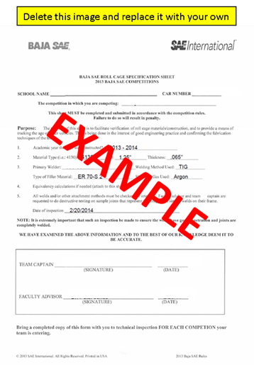

Material Invoice(s)

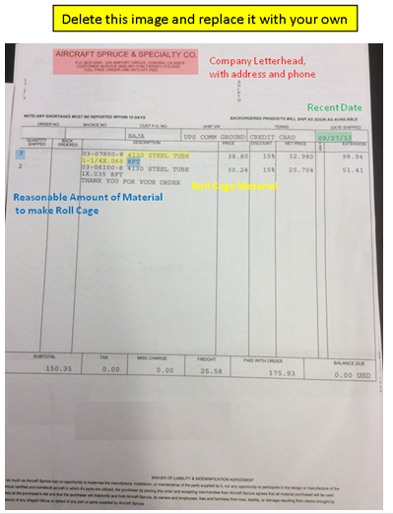

Material Certification(s)

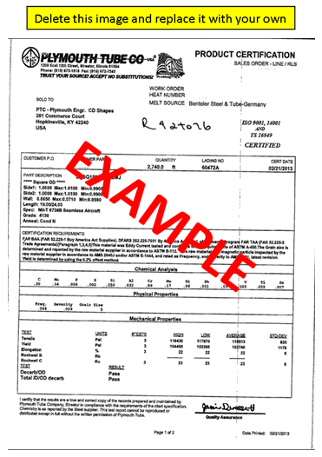

Supporting Calculations (If applicable)
