BajaSAE Frame Design Pre-Check

Roll Cage Geometry Drawings

School Name:
Team Name:

B8.7.3: Pre Frame check Document Response Process:
Documents will be reviewed by the National Technical Inspectors on a first come first serve basis. Typical review period will be 30 days after submittal. After review, feedback will be given to teams only once. It is the responsibility of teams to submit complete documents by the appropriate deadlines. If teams have additional questions they will need to use other resources to find the answers or wait till competition.

Instructions
On the following pages, insert engineering drawings (e.g. CAD models) of your frame in the following standard views. Images should be left in their correct proportions, minimizing any distortion of shape.
- Front
- Side
- Top
- Isometric (front three-quarter view)
- Isometric (rear three-quarter view)
The drawings should note the following items:
- Callouts indicating the material and geometry that is used in the frame, color coding tubes is preferred. (e.g. 4130 Ø1.25 x 0.065; 4130 Ø1.00 x 0.035)
- The major dimensions and angles required to meet the frame rules in B8.3; including:
1. Driver’s seat bottom to SIM height
2. RRH width, per Rule B8.3.3
3. CLC location, per Rule B8.3.4
4. Distance from LDBs to points A and B on RRH, per rule B8.3.3.1
5. Location of driver’s feet
- It is recommended to call out any dimension within 20% of the design limit; for example: bends greater than 24°, LCs of length less than 9.5 inches, Roll Cage members longer than 33 inches…

NEW FOR 2015
Per Rules B8.7 and A6.2, A diagram highlighting what parts of the frame were outsourced or professionally fabricated. An isometric, or other appropriate view, highlighting any component that is not student manufactured; including tube notching, bending and mounting tabs.

Submitting this Document
When you are ready to submit this document, print/convert it to PDF format; the maximum acceptable file size is 10 MB.

Log on to www.bajasae.net and click My Team Document Submissions. There will be a slot for “Frame Design Pre-Check- Roll Cage Geometry Drawings” for each competition. If your frame will not (and does not) change between competitions, you may upload this exact same document for each competition. If your design changes significantly, you should submit an updated document. You can always submit an updated version of the document before the due date listed on the site.

The National Tech Inspector frame specialists will review your submission and mark it as “Accepted” or “Rejected” on CdsWeb. Questions or feedback will be provided for rejected submissions.

Front View

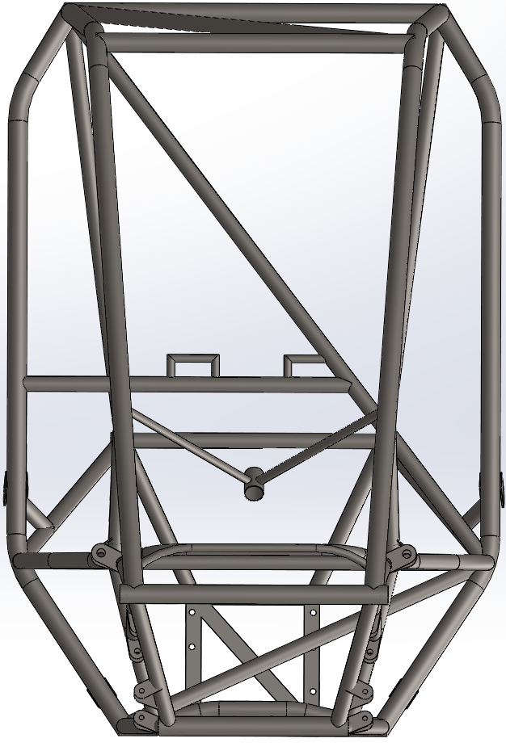
Delete this image and replace it with your own
RRH width 27” above seat

Side View

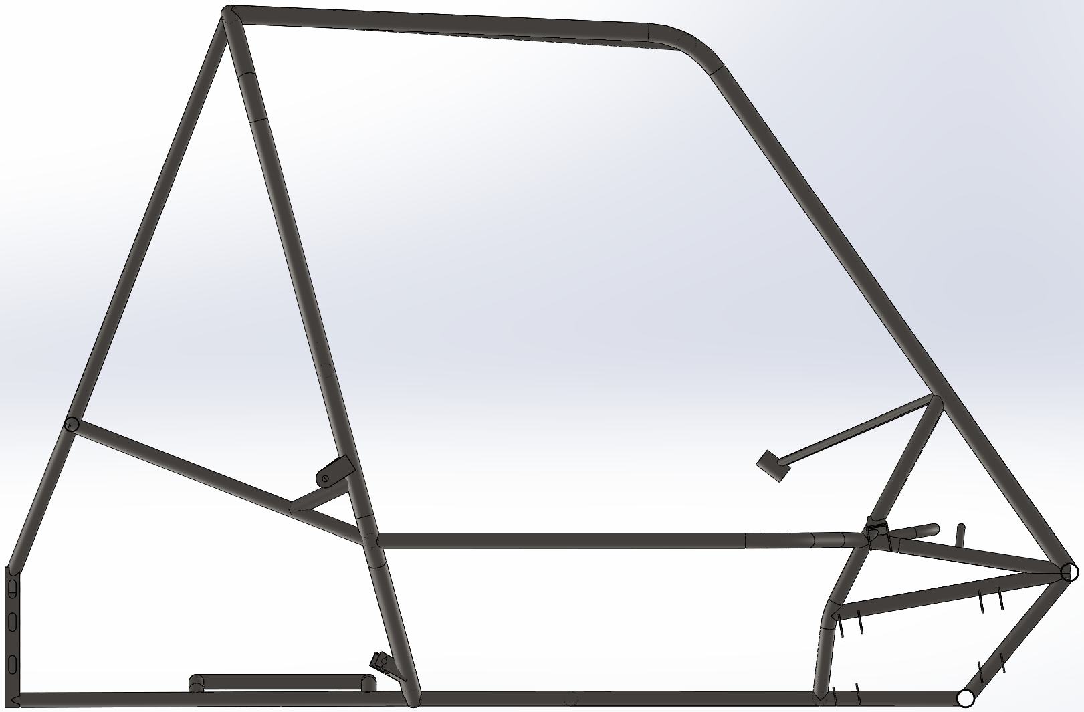
Location of Driver’s feet
Delete this image and replace it with your own
SIM height above seat

Top View

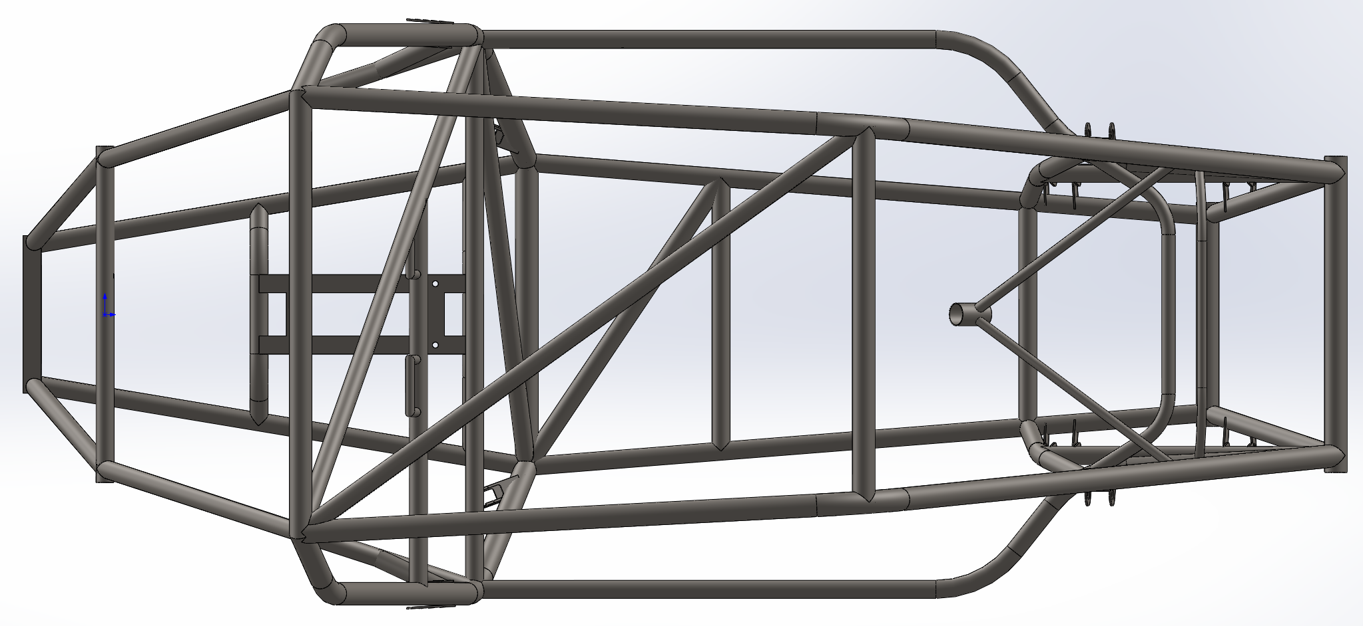
Delete this image and replace it with your own

Isometric View

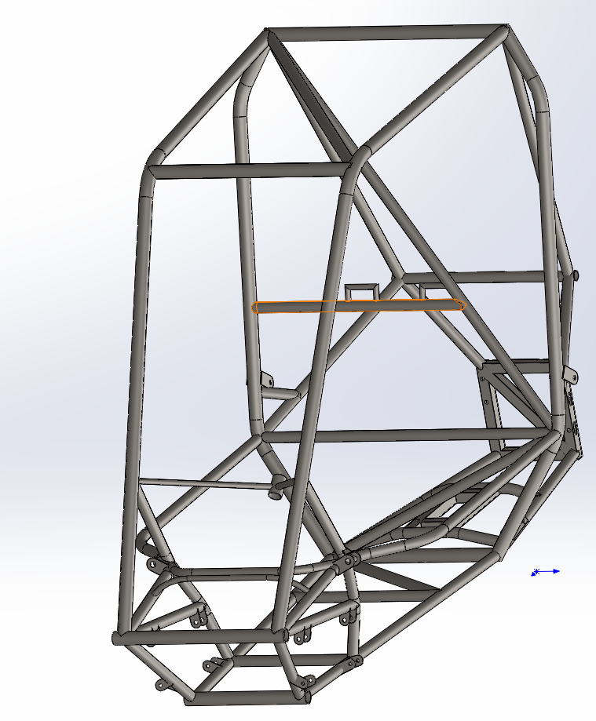
Primary = 4130 1.25”x0.065”
Secondary =4130 1.00x.049”
Delete this image and replace it with your own

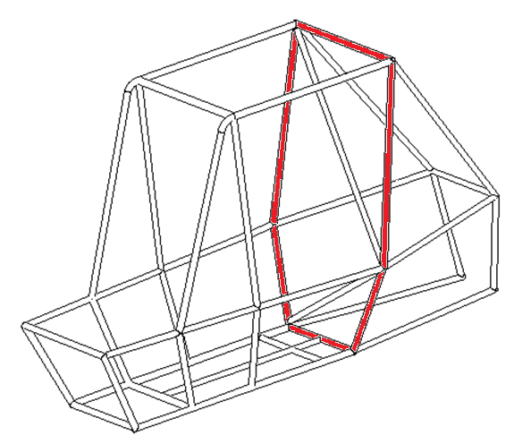
Professionally manufactured

