CO-OP AND INTERNSHIP OPPORTUNITIES
- Operations
- Manufacturing Engineering
- Design Engineering
- Accounting / Finance
- Human Resources

Student Benefits
- Firsthand experience within your career field – bring the classroom to life!
- Extensive development opportunities through a collaborative team environment!
- Hands-on projects with state-of-the-art engineering technology!
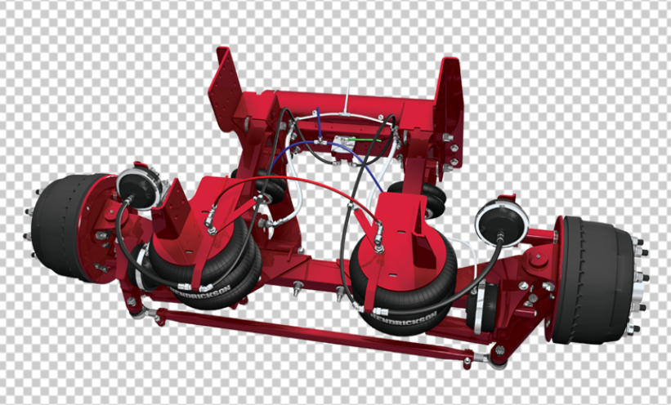
To learn more, contact Human Resources at HAUX_HR@HENDRICKSON-INTL.COM

